Sri Lanka Institute of Information

Technology



Lab Submission

Lab sheet No.7

**IT23329560**

**Palihaderuarachchi W S**

**Probability & Statistics | IT2120**

B.Sc. (Hons) in Information Technology

**Exercise**

2) 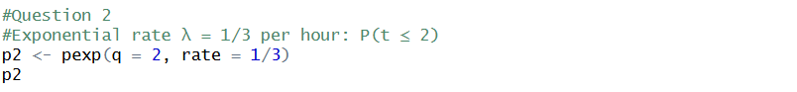

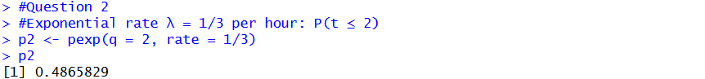

3)

ii) 



